**MONTHALY ASSESSMENT PAPER(NAVTTC)**

**Trainee Name: Muhammad Haroon**

**Father Name: Farooq Ahmed**

**Submitted to: Sir Muhammed Ahmed**

**CNIC: 33202-3217214-3**

**,,,,,,,,,,,,,,,,,,,,,,,,,,,,,,,,,,,,,,,,,,,,,,,,,,,,,,,,,,,,,,,,,,,,,,,,,,,,,,,,,,,,,,,,,,,,,,,,,,,,,,,,,,,,,,,**

**Theoretical**

**Question no: 1** Differentiate between List View and Recycle View?

Solution:

**List View:**

List View is a widget or view in Android that displays a vertical list of scrollable items. Each item in the list is represented by a view, and these views are recycled as the user scrolls through the list. List View is useful when we want to display a simple list of items,

**Recycler View:**

Recycler View is an improved and more flexible version of List View. It's also used to display a list of items, but it addresses the performance issues of List View by introducing a more sophisticated recycling mechanism.

while both List View and Recycler View are used to display lists of items in Android, Recycler View is generally preferred for its enhanced performance and flexibility, especially when dealing with larger or more complex datasets. It's a more modern approach and offers better customization options for creating dynamic and efficient list-based UIs in Android applications.

**Question no: 2 what is SQLite?**

Solution:

SQLite is a software library that provides a relational database management system (RDBMS) in a self-contained, server less, zero-configuration, and transactional manner. It is embedded within the applications that use it, rather than running as a separate server or process. SQLite is designed for efficiency, speed, and simplicity, making it a popular choice for implementing databases in various software applications, including mobile apps, desktop applications, web browsers, and more.

**Part 2: Practical**

**Question No: 1 implement the signup signin secreen with sqlite which perform all crud operation like:**

**1 UPDATE**

**2 DELETE**

**3 CREATE**

**4 RETRIVE**

Also applied validation on required field

**Solution:**

**XML CODE 1:**

<?*xml version*="1.0" *encoding*="utf-8"?>  
<LinearLayout *xmlns:android*="http://schemas.android.com/apk/res/android"  
 *xmlns:tools*="http://schemas.android.com/tools"  
 *android:layout_width*="match_parent"  
 *android:layout_height*="match_parent"  
 *android:orientation*="vertical"  
 *android:layout_margin*="10dp">  
  
 <LinearLayout  
 *android:layout_width*="match_parent"  
 *android:layout_height*="wrap_content"  
 *android:orientation*="horizontal"  
  
 >  
  
 <TextView  
 *android:layout_width*="wrap_content"  
 *android:layout_height*="wrap_content"  
 *android:text*="@string/name"  
 *android:textColor*="#000"  
 *android:textSize*="20sp"  
 />  
  
 <EditText  
 *android:layout_width*="match_parent"  
 *android:layout_height*="wrap_content"  
 *android:id*="@+id/et_name"  
 *android:hint*="@string/h_name"  
 *android:textColor*="#000"/>  
 </LinearLayout>  
  
  
  
 <LinearLayout  
 *android:layout_width*="match_parent"  
 *android:layout_height*="wrap_content"  
 *android:orientation*="horizontal"  
 >  
  
 <TextView  
 *android:layout_width*="wrap_content"  
 *android:layout_height*="wrap_content"  
 *android:text*="@string/course"  
 *android:textColor*="#000"  
 *android:textSize*="20sp"  
  
 />  
  
 <EditText  
 *android:layout_width*="match_parent"  
 *android:layout_height*="wrap_content"  
 *android:id*="@+id/et_course"  
 *android:hint*="@string/h_course"  
 *android:textColor*="#000"/>  
 </LinearLayout>  
  
  
 <LinearLayout  
 *android:layout_width*="match_parent"  
 *android:layout_height*="wrap_content"  
 *android:orientation*="horizontal"  
 >  
  
 <TextView  
 *android:layout_width*="wrap_content"  
 *android:layout_height*="wrap_content"  
 *android:text*="@string/email"  
 *android:textColor*="#000"  
 *android:textSize*="20sp"  
  
 />  
  
 <EditText  
 *android:layout_width*="match_parent"  
 *android:layout_height*="wrap_content"  
 *android:id*="@+id/et_email"  
 *android:hint*="@string/h_email"  
 *android:inputType*="textEmailAddress"  
 *android:textColor*="#000"/>  
 </LinearLayout>  
  
  
 <LinearLayout  
 *android:layout_width*="match_parent"  
 *android:layout_height*="wrap_content"  
 *android:orientation*="horizontal">  
  
 <TextView  
 *android:layout_width*="wrap_content"  
 *android:layout_height*="wrap_content"  
 *android:text*="@string/phone"  
 *android:textColor*="#000"  
 *android:textSize*="20sp"  
  
 />  
  
 <EditText  
 *android:id*="@+id/et_phone"  
 *android:layout_width*="match_parent"  
 *android:layout_height*="wrap_content"  
 *android:hint*="@string/h_phone"  
 *android:inputType*="phone"  
 *android:textColor*="#000" />  
 </LinearLayout>  
  
 <Button  
 *android:layout_width*="match_parent"  
 *android:layout_height*="wrap_content"  
 *android:id*="@+id/btnstore"  
 *android:text*="@string/store"  
 *android:textSize*="20sp"  
 />  
  
</LinearLayout>

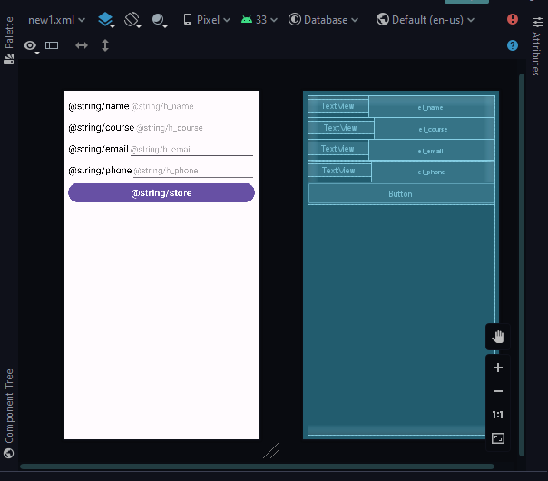

**XML CODE 2:**

<?*xml version*="1.0" *encoding*="utf-8"?>  
<LinearLayout *xmlns:android*="http://schemas.android.com/apk/res/android"  
*xmlns:tools*="http://schemas.android.com/tools"  
*android:layout_width*="match_parent"  
*android:layout_height*="match_parent"  
*android:orientation*="vertical"  
*android:layout_margin*="20dp"  
*tools:context*=".MainActivity">  
  
<Button  
 *android:id*="@+id/btn_add_teacher"  
 *android:layout_width*="match_parent"  
 *android:layout_height*="wrap_content"  
 *android:text*="@string/add" />  
  
<Button  
 *android:id*="@+id/btn_teacher_modify"  
 *android:layout_width*="match_parent"  
 *android:layout_height*="wrap_content"  
 *android:text*="@string/mod" />  
  
<ListView  
 *android:id*="@+id/teachers_lv"  
 *android:layout_width*="match_parent"  
 *android:layout_height*="wrap_content">  
</ListView>  
  
</LinearLayout>

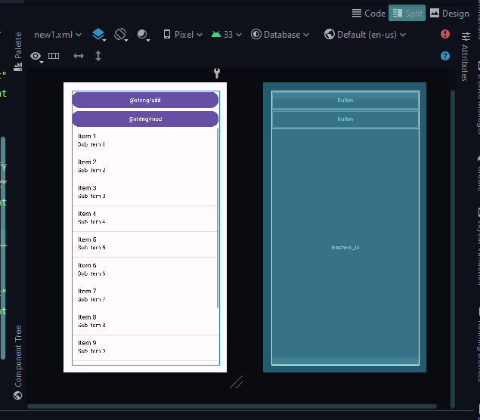

**XML CODE 3:**

<?*xml version*="1.0" *encoding*="utf-8"?>  
<LinearLayout *xmlns:android*="http://schemas.android.com/apk/res/android"  
*xmlns:tools*="http://schemas.android.com/tools"  
*android:layout_width*="match_parent"  
*android:layout_height*="match_parent"  
*android:orientation*="vertical"  
*tools:context*=".ModTeacher">  
  
<TextView  
 *android:layout_width*="match_parent"  
 *android:layout_height*="wrap_content"  
 *android:text*="@string/inst_text"  
 *android:textAlignment*="center"  
 *android:textColor*="#919191"  
 *android:textSize*="20sp" />  
  
<ListView  
 *android:id*="@+id/teachers_lvi"  
 *android:layout_width*="match_parent"  
 *android:layout_height*="wrap_content" />  
  
</LinearLayout>  
  
 <?*xml version*="1.0" *encoding*="utf-8"?>  
<LinearLayout *xmlns:android*="http://schemas.android.com/apk/res/android"  
*xmlns:tools*="http://schemas.android.com/tools"  
*android:layout_width*="match_parent"  
*android:layout_height*="match_parent"  
*android:orientation*="vertical"  
*tools:context*="com.sayem.geeknot.sqlitecrud.ModifyTeachersActivity">  
  
<LinearLayout  
 *android:layout_width*="match_parent"  
 *android:layout_height*="wrap_content"  
 *android:orientation*="horizontal">  
  
 <TextView  
 *android:layout_width*="wrap_content"  
 *android:layout_height*="wrap_content"  
 *android:text*="@string/name"  
 *android:textColor*="#000"  
 *android:textSize*="20sp" />  
  
 <EditText  
 *android:id*="@+id/etname"  
 *android:layout_width*="match_parent"  
 *android:layout_height*="wrap_content"  
 *android:hint*="@string/h_name"  
 *android:textColor*="#000"  
 *android:textSize*="20sp" />  
</LinearLayout>  
  
<LinearLayout  
 *android:layout_width*="match_parent"  
 *android:layout_height*="wrap_content"  
 *android:orientation*="horizontal"  
 *android:paddingTop*="5dp">  
  
 <TextView  
 *android:layout_width*="wrap_content"  
 *android:layout_height*="wrap_content"  
 *android:text*="@string/course"  
 *android:textColor*="#000"  
 *android:textSize*="20sp" />  
  
 <EditText  
 *android:id*="@+id/etcourse"  
 *android:layout_width*="match_parent"  
 *android:layout_height*="wrap_content"  
 *android:hint*="@string/h_course"  
 *android:textColor*="#000"  
 *android:textSize*="20sp" />  
</LinearLayout>  
  
<LinearLayout  
 *android:layout_width*="match_parent"  
 *android:layout_height*="wrap_content"  
 *android:orientation*="horizontal"  
 *android:paddingTop*="5dp">  
  
 <TextView  
 *android:layout_width*="wrap_content"  
 *android:layout_height*="wrap_content"  
 *android:text*="@string/email"  
 *android:textColor*="#000"  
 *android:textSize*="20sp" />  
  
 <EditText  
 *android:id*="@+id/etemail"  
 *android:layout_width*="match_parent"  
 *android:layout_height*="wrap_content"  
 *android:hint*="@string/h_email"  
 *android:inputType*="textEmailAddress"  
 *android:textColor*="#000"  
 *android:textSize*="20sp" />  
  
</LinearLayout>  
  
<LinearLayout  
 *android:layout_width*="match_parent"  
 *android:layout_height*="wrap_content"  
 *android:orientation*="horizontal"  
 *android:paddingTop*="5dp">  
  
 <TextView  
 *android:layout_width*="wrap_content"  
 *android:layout_height*="wrap_content"  
 *android:text*="@string/phone"  
 *android:textColor*="#000"  
 *android:textSize*="20sp" />  
  
 <EditText  
 *android:id*="@+id/etphone"  
 *android:layout_width*="match_parent"  
 *android:layout_height*="wrap_content"  
 *android:inputType*="phone"  
 *android:hint*="@string/h_phone"  
 *android:textColor*="#000"  
 *android:textSize*="20sp" />  
  
</LinearLayout>  
  
<Button  
 *android:id*="@+id/btnupdate"  
 *android:layout_width*="match_parent"  
 *android:layout_height*="wrap_content"  
 *android:text*="@string/update"  
 *android:textSize*="20sp" />  
  
<Button  
 *android:id*="@+id/btndelete"  
 *android:layout_width*="match_parent"  
 *android:layout_height*="wrap_content"  
 *android:text*="@string/delete"  
 *android:textSize*="20sp" />  
  
</LinearLayout>

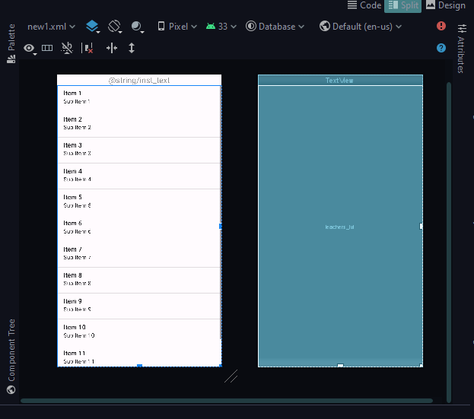

**XML CODE 4:**

<?*xml version*="1.0" *encoding*="utf-8"?>  
<LinearLayout *xmlns:android*="http://schemas.android.com/apk/res/android"  
*xmlns:app*="http://schemas.android.com/apk/res-auto"  
*android:orientation*="vertical"  
*android:layout_width*="match_parent"  
*android:layout_height*="match_parent">  
<androidx.cardview.widget.CardView  
 *android:layout_width*="match_parent"  
 *android:layout_margin*="20dp"  
 *app:cardElevation*="10dp"  
 *app:cardCornerRadius*="10dp"  
 *android:layout_height*="wrap_content">  
  
 <LinearLayout  
 *android:layout_width*="match_parent"  
 *android:orientation*="vertical"  
 *android:layout_margin*="10dp"  
 *android:layout_height*="wrap_content">  
 <TextView  
 *android:id*="@+id/teachers_name"  
 *android:layout_width*="match_parent"  
 *android:layout_height*="wrap_content"  
 *android:textColor*="#000"  
 *android:gravity*="center_vertical"  
 *android:textSize*="20sp"  
 *android:text*="@string/name"  
 *android:layout_marginTop*="10dp"/>  
  
 <TextView  
 *android:id*="@+id/teachers_course"  
 *android:layout_width*="match_parent"  
 *android:layout_height*="wrap_content"  
 *android:textColor*="#000"  
 *android:textSize*="20sp"  
 *android:text*="@string/course"  
 *android:layout_marginTop*="10dp"/>  
  
 <TextView  
 *android:id*="@+id/teachers_email"  
 *android:layout_width*="match_parent"  
 *android:layout_height*="wrap_content"  
 *android:textColor*="#000"  
 *android:textSize*="20sp"  
 *android:text*="@string/email"  
 *android:layout_marginTop*="10dp"/>  
  
 <TextView  
 *android:id*="@+id/teachers_phone"  
 *android:layout_width*="wrap_content"  
 *android:layout_height*="wrap_content"  
 *android:textColor*="#000"  
 *android:textSize*="20sp"  
 *android:text*="@string/phone"  
 *android:layout_marginTop*="10dp"  
 *android:layout_marginBottom*="10dp"/>  
  
 </LinearLayout>  
</androidx.cardview.widget.CardView>  
</LinearLayout>

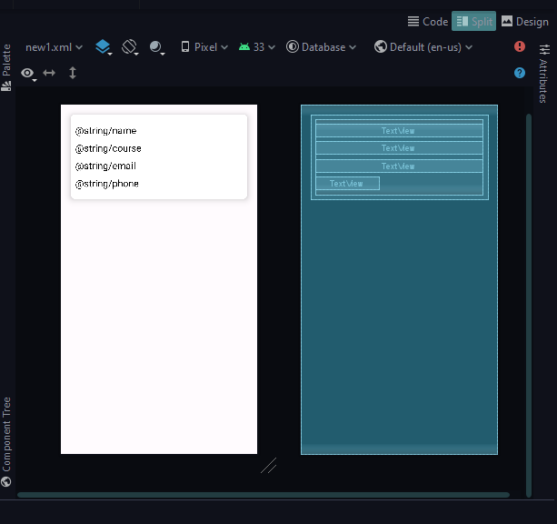

**XML CODE 5:**

<?*xml version*="1.0" *encoding*="utf-8"?>  
<LinearLayout *xmlns:android*="http://schemas.android.com/apk/res/android"  
*android:layout_width*="match_parent"  
*android:layout_height*="match_parent"  
*xmlns:app*="http://schemas.android.com/apk/res-auto"  
  
*android:orientation*="vertical">  
<androidx.cardview.widget.CardView  
 *android:layout_width*="match_parent"  
 *android:layout_margin*="20dp"  
 *app:cardElevation*="10dp"  
 *app:cardCornerRadius*="10dp"  
 *android:layout_height*="wrap_content">  
 <LinearLayout  
 *android:layout_width*="match_parent"  
 *android:orientation*="vertical"  
 *android:layout_margin*="10dp"  
 *android:layout_height*="wrap_content">  
 <TextView  
 *android:id*="@+id/teachers_name"  
 *android:layout_width*="match_parent"  
 *android:layout_height*="wrap_content"  
 *android:textColor*="#000"  
 *android:textSize*="20sp"  
 *android:text*="@string/name"  
 *android:layout_marginTop*="10dp"/>  
  
 <TextView  
 *android:id*="@+id/teachers_course"  
 *android:layout_width*="match_parent"  
 *android:layout_height*="wrap_content"  
 *android:textColor*="#000"  
 *android:textSize*="20sp"  
 *android:text*="@string/course"  
 *android:layout_marginTop*="10dp"/>  
  
 <TextView  
 *android:id*="@+id/teachers_email"  
 *android:layout_width*="match_parent"  
 *android:layout_height*="wrap_content"  
 *android:textColor*="#000"  
 *android:textSize*="20sp"  
 *android:text*="@string/email"  
 *android:layout_marginTop*="10dp"/>  
  
 <LinearLayout  
 *android:layout_width*="match_parent"  
 *android:layout_height*="wrap_content"  
 *android:orientation*="horizontal"  
 *android:layout_marginTop*="10dp">  
  
 <TextView  
 *android:layout_width*="wrap_content"  
 *android:layout_height*="wrap_content"  
 *android:textColor*="#000"  
 *android:textSize*="20sp"  
 *android:text*="@string/phone" />  
  
 <TextView  
 *android:id*="@+id/teachers_phone"  
 *android:layout_width*="wrap_content"  
 *android:layout_height*="wrap_content"  
 *android:textSize*="20sp"  
 *android:textColor*="#000" />  
  
 </LinearLayout>  
  
  
 </LinearLayout>  
  
</androidx.cardview.widget.CardView>  
</LinearLayout>

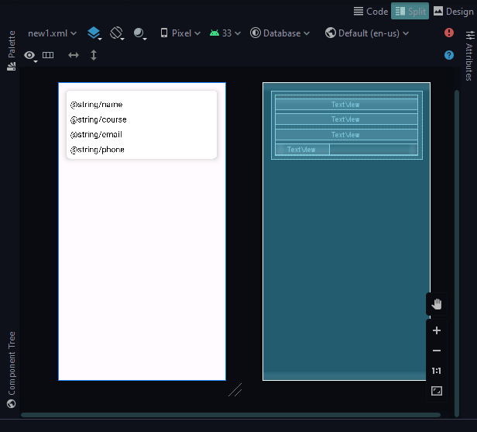

**Question no:2 Implement the Photos app which take a picture from your phone gallery?**

**Solution**:

**XML Code:**

<?*xml version*="1.0" *encoding*="utf-8"?>  
<RelativeLayout *xmlns:android*="http://schemas.android.com/apk/res/android"  
 *xmlns:app*="http://schemas.android.com/apk/res-auto"  
 *xmlns:tools*="http://schemas.android.com/tools"  
 *android:layout_width*="match_parent"  
 *android:layout_height*="match_parent"  
 *android:padding*="10dp"  
 *tools:context*=".MainActivity">  
  
 <TextView  
 *android:id*="@+id/tv"  
 *android:layout_width*="wrap_content"  
 *android:layout_height*="wrap_content"  
 *android:text*="Enter Your Name"  
 *android:textSize*="24dp"  
 >  
  
 </TextView>  
  
 <EditText  
 *android:id*="@+id/et1"  
 *android:layout_width*="match_parent"  
 *android:layout_height*="wrap_content"  
 *android:textSize*="24dp"  
 *android:layout_below*="@+id/tv"/>  
 <Button  
 *android:id*="@+id/bt"  
 *android:layout_width*="match_parent"  
 *android:layout_height*="wrap_content"  
 *android:text*="Save"  
 *android:layout_below*="@+id/et1"  
 *android:textSize*="24dp"  
 />  
 <TextView  
 *android:id*="@+id/tv1"  
 *android:layout_width*="wrap_content"  
 *android:layout_height*="wrap_content"  
 *android:textSize*="24dp"  
 *android:layout_below*="@+id/bt"  
 *android:layout_centerHorizontal*="true"  
 *android:textAlignment*="center">  
  
 </TextView>  
  
 <ImageView  
 *android:id*="@+id/image"  
 *android:layout_width*="200dp"  
 *android:layout_height*="200dp"  
 *android:layout_below*="@+id/tv1"  
 *android:layout_centerHorizontal*="true"  
  
  
  
  
  
</RelativeLayout>

**Shape:**

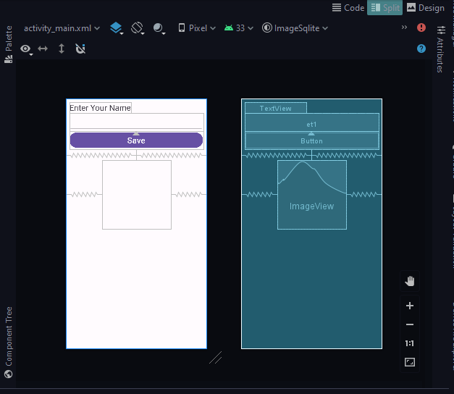

**MAIN JAVA CODE:**

*package* com.example.imagesqlite;  
  
*import* androidx.appcompat.app.AppCompatActivity;  
  
*import* android.graphics.Bitmap;  
*import* android.graphics.BitmapFactory;  
*import* android.os.Bundle;  
*import* android.view.View;  
*import* android.widget.Button;  
*import* android.widget.EditText;  
*import* android.widget.ImageView;  
*import* android.widget.TextView;  
  
*import* java.io.ByteArrayInputStream;  
  
*public class* MainActivity *extends* AppCompatActivity {  
  
 TextView textView, textview1;  
 EditText editText;  
 ImageView imageView;  
 Button button;  
  
 @Override  
 *protected void* onCreate(Bundle savedInstanceState) {  
 *super*.onCreate(savedInstanceState);  
 setContentView(R.layout.*activity_main*);  
 textView= (TextView) findViewById(R.id.*tv*);  
 textview1= (TextView) findViewById(R.id.*tv1*);  
 editText= (EditText) findViewById(R.id.*et1*);  
 imageView= (ImageView) findViewById(R.id.*image*);  
 button= (Button) findViewById(R.id.*bt*);  
  
 button.setOnClickListener(*new* View.OnClickListener() {  
 @Override  
 *public void* onClick(View v) {  
 String name = editText.getText().toString();  
 Bitmap bitmap= BitmapFactory.*decodeResource*(getResources(),R.drawable.*draw*);  
 ByteArrayInputStream byteArrayInputStream= *new* ByteArrayInputStream( );  
 bitmap.compress(Bitmap.CompressFormat.***PNG***,100,byteArray);  
 *byte*[] img= byteArray.toByteArray{};  
  
  
  
 }  
 });  
  
 }  
}

**DATABASE JAVA:**

*import* android.content.Context;  
*import* android.database.sqlite.SQLiteDatabase;  
*import* android.database.sqlite.SQLiteOpenHelper;  
  
*import* androidx.annotation.Nullable;  
  
*public class* MyDataBase *extends* SQLiteOpenHelper {  
 *public* MyDataBase( Context context ) {  
 *super*(context,"Name",*null*,1);  
 }  
  
 @Override  
 *public void* onCreate(SQLiteDatabase db) {  
  
 }  
  
 @Override  
 *public void* onUpgrade(SQLiteDatabase db, *int* oldVersion, *int* newVersion) {  
  
 }  
}

**QUESTION NO :3 RECYCLER VIEW ALSO IMPLEMENT THE SCROLLING INTERFACE?**

**SOLUTION:**

**Main xml;**

<?*xml version*="1.0" *encoding*="utf-8"?>  
<androidx.appcompat.widget.LinearLayoutCompat *xmlns:android*="http://schemas.android.com/apk/res/android"  
 *xmlns:app*="http://schemas.android.com/apk/res-auto"  
 *xmlns:tools*="http://schemas.android.com/tools"  
 *android:layout_width*="match_parent"  
 *android:layout_height*="match_parent"  
 *android:orientation*="vertical"  
 *tools:context*=".MainActivity">  
  
 <androidx.cardview.widget.CardView  
 *android:layout_width*="match_parent"  
 *android:layout_height*="wrap_content"  
 *app:cardCornerRadius*="20sp"  
 *app:cardElevation*="20sp"  
 *android:layout_margin*="10sp"  
  
 >  
  
 <LinearLayout  
 *android:layout_width*="match_parent"  
 *android:layout_height*="wrap_content"  
 *android:background*="#8B4D0900"  
 >  
  
  
 <TextView  
 *android:layout_width*="match_parent"  
 *android:layout_height*="wrap_content"  
 *android:textStyle*="bold"  
 *android:textAlignment*="center"  
 *android:layout_gravity*="center"  
 *android:text*="RecyclerSample"  
 *android:textColor*="#6D0830"  
 *android:textSize*="24dp"  
 >  
  
 </TextView>  
 </LinearLayout>  
  
 </androidx.cardview.widget.CardView>  
 <androidx.recyclerview.widget.RecyclerView  
 *android:id*="@+id/recycler"  
 *android:layout_width*="match_parent"  
 *tools:listitem*="@layout/item_list"  
 *tools:itemCount*="5"  
  
 *android:layout_height*="wrap_content"  
 *tools:layout_editor_absoluteX*="-2dp"  
 *tools:layout_editor_absoluteY*="-2dp"/>  
  
</androidx.appcompat.widget.LinearLayoutCompat>

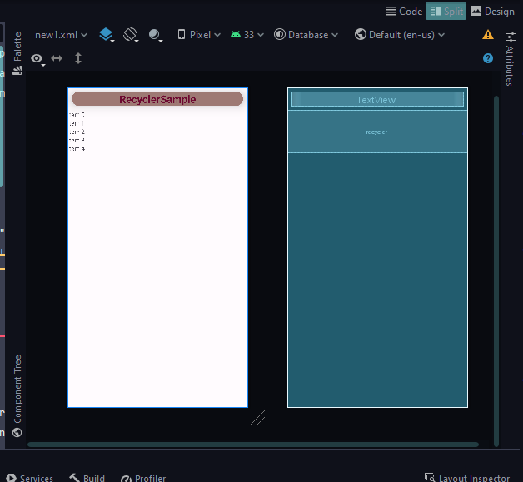**Card view xml;**

<?*xml version*="1.0" *encoding*="utf-8"?>  
<androidx.cardview.widget.CardView *xmlns:android*="http://schemas.android.com/apk/res/android"  
 *xmlns:app*="http://schemas.android.com/apk/res-auto"  
 *android:layout_width*="match_parent"  
 *android:layout_height*="wrap_content"  
 *android:layout_margin*="10dp"  
 *app:cardElevation*="10sp"  
 *app:cardCornerRadius*="15sp"  
  
 >  
  
  
 <LinearLayout  
 *android:layout_width*="match_parent"  
 *android:layout_height*="wrap_content"  
 *android:orientation*="horizontal"  
 >  
  
 <ImageView  
 *android:id*="@+id/img"  
 *android:layout_width*="100sp"  
 *android:layout_height*="120sp"  
 *android:src*="@drawable/Vivo V20">  
  
 </ImageView>  
 </LinearLayout>  
  
 <LinearLayout  
 *android:layout_width*="wrap_content"  
 *android:layout_height*="match_parent"  
 *android:layout_marginLeft*="155sp"  
 *android:orientation*="vertical"  
 >  
  
  
  
 <TextView  
 *android:id*="@+id/mobile_model"  
 *android:layout_width*="match_parent"  
 *android:layout_height*="wrap_content"  
 *android:layout_margin*="7sp"  
 *android:fontFamily*="@font/artifika"  
 *android:text*="Samsung S23 Ultra"  
 *android:textSize*="15sp"  
 *android:textStyle*="bold">  
  
 </TextView>  
  
 <TextView  
 *android:id*="@+id/ram_rom"  
 *android:layout_width*="match_parent"  
 *android:layout_height*="wrap_content"  
 *android:layout_marginLeft*="10sp"  
 *android:text*="8GB, 128GB "  
 *android:textSize*="12sp">  
  
 </TextView>  
  
 <TextView  
 *android:id*="@+id/rating"  
 *android:layout_width*="match_parent"  
 *android:layout_height*="wrap_content"  
 *android:layout_marginLeft*="13sp"  
 *android:layout_marginTop*="5sp"  
 *android:text*="6.3 Rating"  
 *android:textSize*="12sp">  
  
 </TextView>  
  
 <TextView  
 *android:id*="@+id/price"  
 *android:layout_width*="match_parent"  
 *android:layout_height*="wrap_content"  
 *android:layout_marginLeft*="10sp"  
 *android:layout_marginTop*="6sp"  
 *android:text*="PKR 60,000.0"  
 *android:textSize*="15sp"  
 *android:textStyle*="bold">  
  
 </TextView>  
 </LinearLayout>  
</androidx.cardview.widget.CardView>

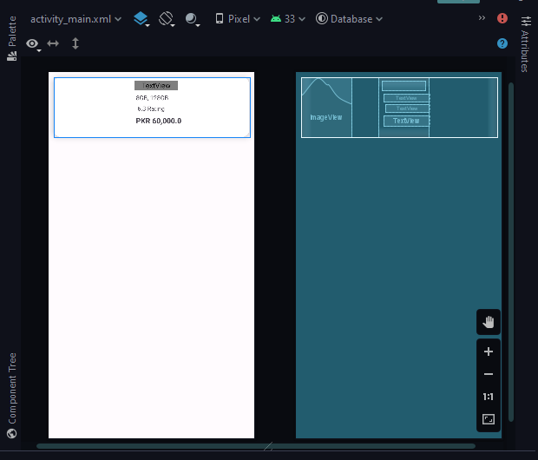

**,,,,,,,,,,,,,,,,,,,,,,,,,,,,,,,,,,,,,,,,,,,,The End,,,,,,,,,,,,,,,,,,,,,,,,,,,,,,,,,,,,,,,,,,,,,,,**